Assessment Team Report

The Assessment Team comprised of the following three members visited the Department of Agricultural Extension Education & Communication on June 11, 2012 in order to assess its B.Sc (Hons) Degree Program:

- Dr. Muhammad Zafarullah Khan Convener AT
(Chairman, Department of Agric. Extension Educ. & Comm)

- Prof. Dr. Khalid Nawab AT Member
(Professor, Agric. Extension Educ. & Comm department)

- Mr. Allah Dad Khan AT Member
(Ex. Director General Extension)

- Dr. Fayaz ud Din Qazi External AT Member
(Deputy Director Planning,
Directorate of Agriculture (Extension)
Khyber Pakhtunkhwa)

The above committee in its meeting with the Chairman and Dean identified the following Strength and Weaknesses of Program:

Strengths:

- Most of the faculty members holding Ph.D, in different areas of Agricultural Extension.

- One faculty member did Post Doc from Thailand and another one is currently abroad for Post Doc.

- Communication Laboratory facility is available at department.

- FM Radio Station establishment is under process.

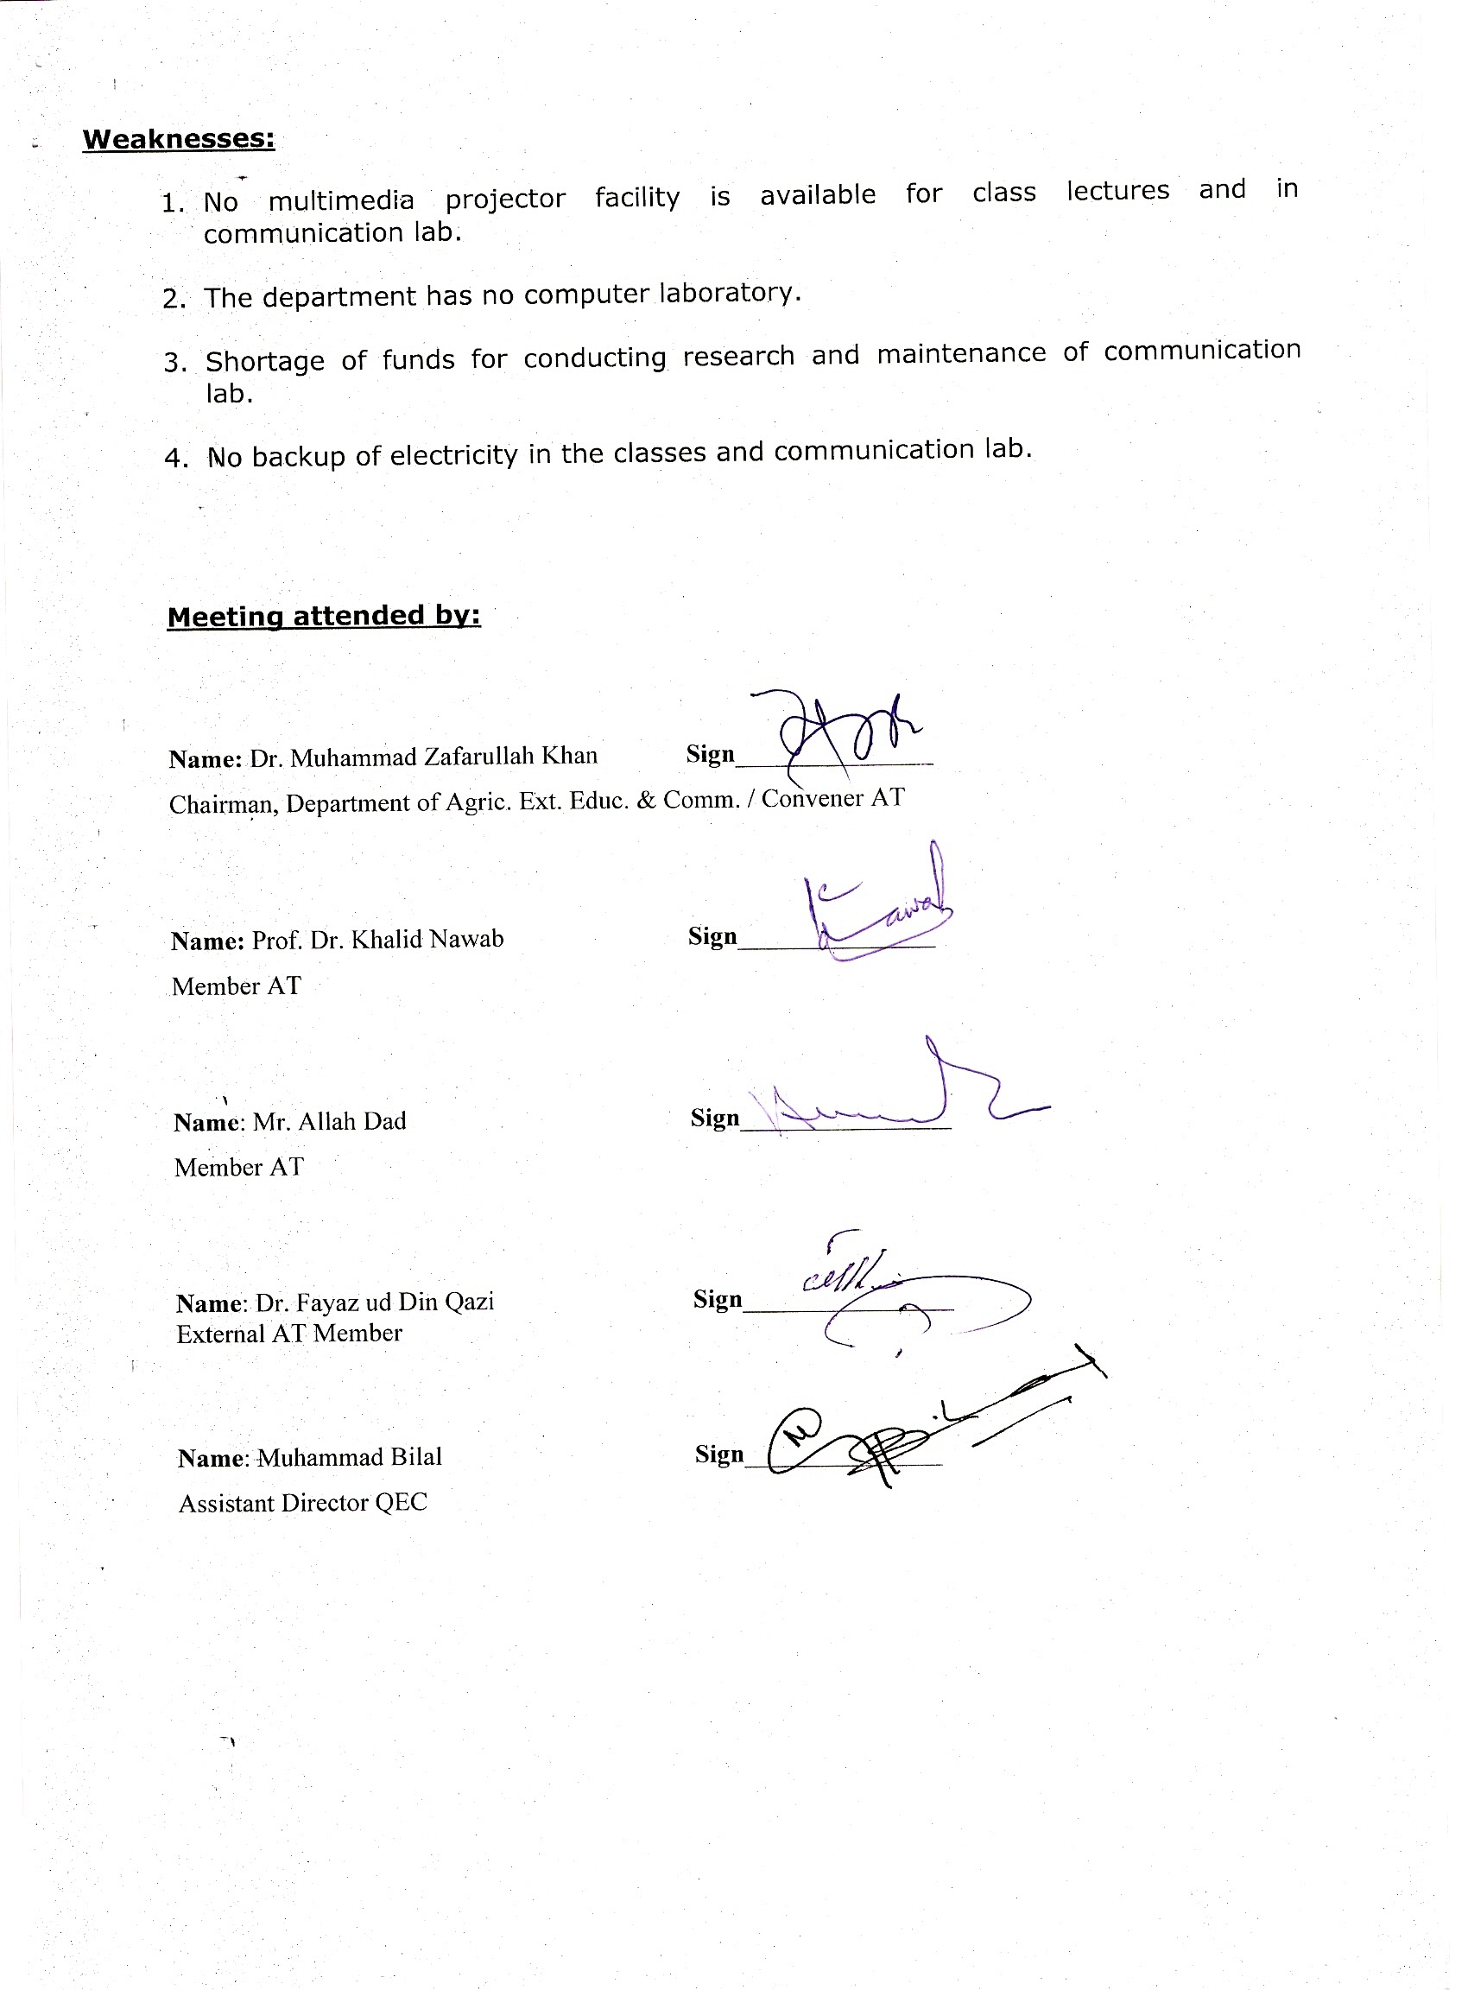

Weaknesses:

- No multimedia projector facility is available for class lectures and in communication lab.

- The department has no computer laboratory.

- Shortage of funds for conducting research and maintenance of communication lab.

- No backup of electricity in the classes and communication lab.

Meeting attended by:

Name: Dr. Muhammad Zafarullah Khan Sign_______________
Chairman, Department of Agric. Ext. Educ. & Comm. / Convener AT

Name: Prof. Dr. Khalid Nawab Sign_______________
Member AT

Name: Mr. Allah Dad Sign________________
Member AT

Name: Dr. Fayaz ud Din Qazi Sign________________
External AT Member

Name: Muhammad Bilal Sign_______________
Assistant Director QEC

